Lesson 6
Polarimetry method.
Polarimetry is a method of physical research based on measuring the degree of polarization of light and the angle of rotation of the plane of polarization of light as it passes through optically active substances.
Polarimetric analysis is a method that can only be used to study, identify, quantify specific objects - chiral (optically active) substances. To solve all these problems, a rather specific means called polarized light should also be used. Thus, polarimetric analysis is a method based on measuring the angle of rotation of the polarization plane of linearly polarized light by optically active substances.
Optically active substances having an asymmetric molecular or crystalline structure rotate the polarization plane of linearly polarized light by an angle α - the angle of rotation of the polarization plane.
The angle of rotation of the plane of polarization depends on the nature of the optically active substance, concentration (for solutions), wavelength of light, temperature, nature of the solvent.
The quantity characterizing the dependence of the angle of rotation of the polarization plane on the wavelength dα/dl is called the optical rotation dispersion.
The value of α is proportional to the thickness of the substance layer and the concentration of the solution.
The main condition for chirality and, consequently, for the optical activity of a substance is the absence of a center, a plane of a mirror-rotary symmetry axis in its molecules.
Structural optical activity, i.e. The ability to rotate the plane of polarization in the solid state can be possessed by crystals built from both chiral and non-chiral molecules.
When polarized light passes through an optically active medium, two effects can occur:
– change in the direction of oscillations – rotation of the plane of polarization;
- decomposition of a linearly polarized beam into two components that have rotation in different directions - the phenomenon of circular dichroism).
Optical rotation is the property of a substance to rotate the plane of polarization when polarized light passes through it. Depending on the nature of the optically active substance, the rotation of the polarization plane can have a different direction and magnitude. If the polarization plane rotates clockwise from the observer to whom the light passing through the optically active substance is directed, then the substance is called dextrorotatory and the sign d (from the word dexter - right) or the sign (+) is placed before its name; if the plane of polarization rotates counterclockwise, then the substance is called left-handed and the sign l (from the word laevus - left) or the sign (–) is placed before its name. A racemate is an equimolar mixture of two enantiomers, i.e. a mixture of a left and right rotating isomer (1:1). Racemates are shown as d,l- or (+/-).
The angle of rotation of the plane of polarization of a linearly polarized beam by an optically active substance depends on the structure of this substance, the path length l of the light beam in it, and does not depend on its intensity.
For a comparative assessment of the ability of various substances to rotate the plane of polarization of light, the value of the specific rotation 〖[α]〗_D^20 is calculated. Specific optical rotation 〖[α]〗_D^20 is the angle of rotation  of the plane of polarization of monochromatic light at the wavelength of the D line of the sodium spectrum (589.3 nm), expressed in degrees, measured at a temperature of 20 ° C, calculated for the thickness of the layer of the test substance 1 dm and reduced to a concentration of a substance equal to 1 g / ml. Expressed in degrees milliliter per decimeter gram [deg ml dm-1 g -1 ].
For liquid substances, the value 〖[α]〗_D^20 is determined by the formula:
Where,
 is the measured angle of rotation, in degrees;
l is the layer thickness, in decimeters;
❒ is the density of the solution.
When determining 〖[α]〗_D^20 in solutions of an optically active substance, it must be borne in mind that the found value may depend on the nature of the solvent and the concentration of the optically active substance. Changing the solvent can lead to a change in 〖[α]〗_D^20 not only in magnitude but also in sign. Therefore, when giving the value of specific rotation, it is necessary to indicate the solvent and the concentration of the solution chosen for measurement.
Specific rotation is determined either in terms of dry matter, or from a dried sample, which should be indicated in a monograph. Measurement of the angle of rotation is carried out on a polarimeter, which allows to determine the value of the angle of rotation with an accuracy of ±0.02 °C, at a temperature of (20 ± 0.5) °C. Measurement of optical rotation can also be carried out at other temperatures, but in such cases, the method of taking into account the temperature should be indicated in the monograph. The scale is usually checked using certified quartz plates. The linearity of the scale can be checked with sucrose solutions.
The optical rotation of the solutions must be measured within 30 minutes of their preparation; solutions or liquid substances must be transparent. When changing, first of all, you should set the zero point of the device or determine the correction value with a tube filled with pure solvent (when working with solutions), or with an empty tube (when working with liquid substances). After setting the device to the zero point or determining the magnitude of the correction, the main change is carried out, which is repeated at least 3 times.
To obtain the value of the rotation angle , the instrument readings obtained during measurements are algebraically summed up with the previously found correction value.
The specific rotation value 〖[α]〗_D^20 is calculated using one of the following formulas.
For substances in solution:
Where:
 is the measured angle of rotation, in degrees;
l is the layer thickness, in decimeters;
C is the concentration of the solution, in grams of the substance per 100 ml of the solution.
Changing the angle of rotation is carried out either to assess the purity of the optically active substance, or to determine its concentration in solution. To assess the purity of a substance using equation (1) or (2), the value of its specific rotation 〖[α]〗_D^20 is calculated.
The concentration of an optically active substance in a solution is found by the formula:
Mutarotation (from Latin muto - I change and rotatio - rotation) - a change in the magnitude of the optical rotation of solutions of optically active compounds due to the mutual transition of the anomers of a substance into each other. It is typical for monosaccharides, reducing oligosaccharides, lactones, etc. In the case of glucose, mutarotation is explained by the establishment of equilibrium: in the equilibrium state, there are 36% of the alpha form and 64% of the beta form. The intermediate aldehyde form is contained in a negligible concentration. The predominant formation of the β-form is explained by the fact that it is more thermodynamically stable.
Instruments for polarimetric analysis
The angle of rotation of the plane of polarization of a linearly polarized beam by optically active substances can be measured using special instruments: polarimeters, saccharimeters. Polarimeters and saccharimeters are designed to measure the angles of rotation of the plane of polarization at a constant wavelength of linearly polarized light.
The main functional units of all these devices are a light source, a polarizer, an analyzer, a polarizing tube, and a recording device.
As light sources in polarimeters, lamps with a narrow discrete spectrum of emitted radiation are used, for example, a DNaS 18-04.2 lamp.
The selection of radiation with a wavelength corresponding to the yellow line in the spectrum of sodium (589.5 nm), on which, in most laboratory measurements, the angle of rotation of the polarization plane in polarimeters is determined using a light filter.
The polarizer and analyzer of any polarimetric device are prisms or plates made of an optically active mineral, for example, a Nicol prism made of Iceland spar, a plate made of right- or left-handed quartz, polaroid films made of complex organic compounds of iodine.
In most polarimeters, detection of measurement results is carried out visually.
The principle of operation of all polarimetric devices is based on equalizing the illumination of two parts of the field of view of the eyepiece of the device near darkness.
On fig. the appearance of a simple, but widely used in laboratory (including industrial) practice circular polarimeter is presented.
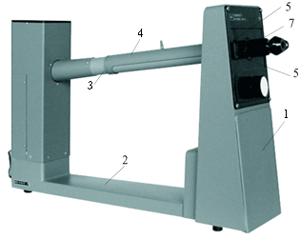
Drawing. The appearance of the circular polarimeter:
1 - body; 2 - base assembly; 3 – cell compartment body; 4 - cover; 5 - limbus; 6 - verniers of reading devices; 7 - bushing for setting the image sharpness.
Structurally, this device consists of the following main components: body 1, analyzer head with a linear polarizer, which is the measuring part of the polarimeter, which is located in body 1, base assembly 2, cell compartment body 3 with cover 4. On the front panel of the device body there are transparent windows in which diametrically located sections of the limb 5 are visible, fixed on a spur gear located inside the housing. The dial has a 360-degree scale with a division value of 0.5 degrees. The verniers of reading devices 6 are also fixed inside the case. Each vernier has 25 divisions. The price of division by vernier is 0.02o. Rotation of the dial is carried out by the handle 7, located on the front panel of the device.
On the front panel of the device is the front end of the observation tube, which contains the lens, diaphragm and eyepiece. The observation tube is set on a sharp image of the dividing line of the field of view in the eyepiece by rotating the sleeve 7.
On the rear panel of the device there is a toggle switch to turn on the light source and two fuses.
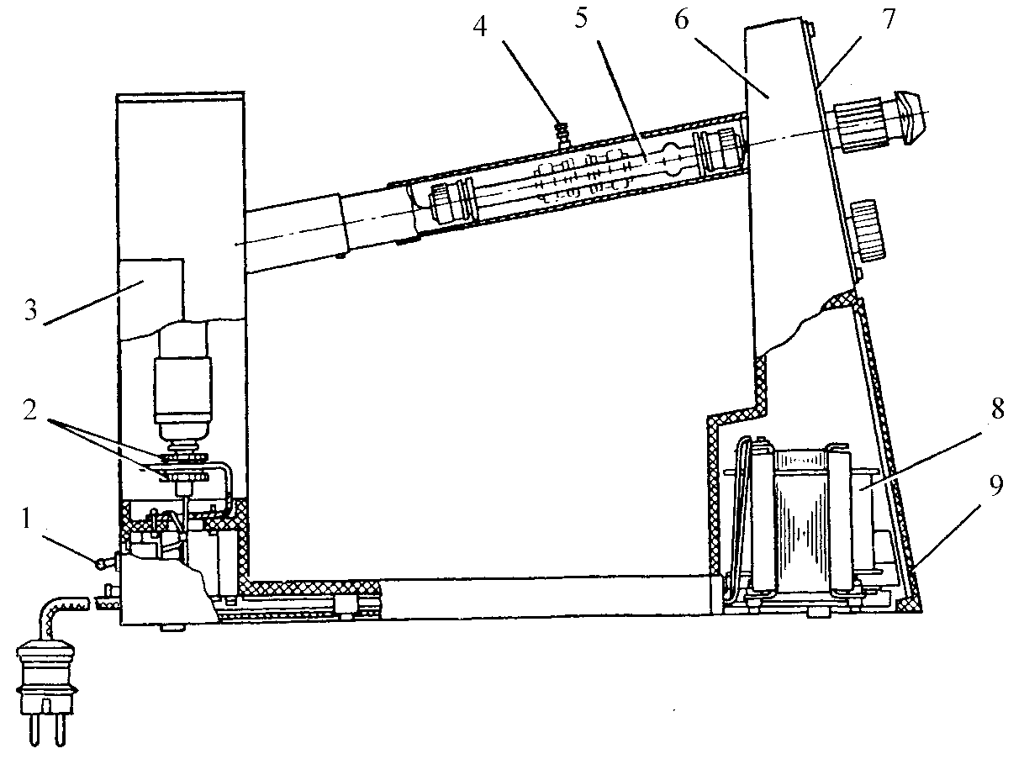
Drawing. General view of the circular polarimeter in section:
The analyzed substance is placed in a cuvette (polarimetric tube), which consists of a glass tube with bushings, coverslips, gaskets, bushings and nuts. The glass tube has a raised area that is needed to collect air bubbles.
Schematic optical diagram of a circular polarimeter.
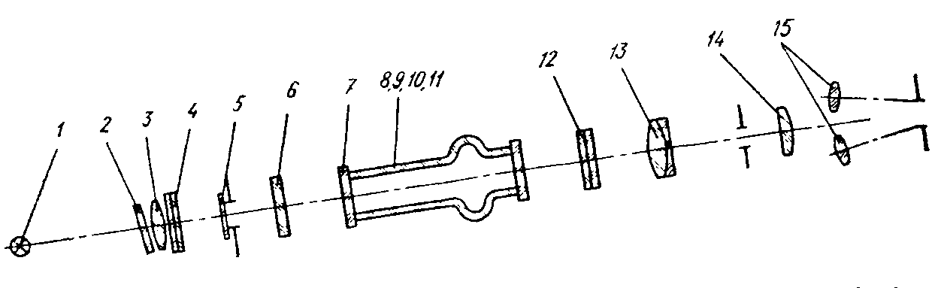
1– brand lamp; 2-light filter: 3-condenser; 4 - polarizer; 5—chromatic phase plate, 6—protective glass, 7—two cover glasses; 8, 9, 10 and 11 - tubes; 12 – analyzer; 13 - lens; 14 - eyepiece; 15 - two magnifiers.
In the device of this design, the principle of equalizing the illumination of the field of view divided into two parts in the eyepiece 14 is applied. The division of the field of view into two halves is carried out by introducing a chromatic phase plate 5 into the optical system of the polarimeter. and the analyzer, with equal minimum illumination of the comparison fields, make an angle of 86.5o.
The light from the lamp, passing through the condenser lens 3 and polarizer 4, passes through the chromatic phase plate 5, protective glass 6, cuvette (polarimetric tube) and analyzer 12 with one part of the beam, and only through protective glass 6, cuvette and analyzer 12 with the other part of the beam In this case, one half of the reference field in the eyepiece is illuminated, while the other is darkened.
Illumination equalization of the comparison fields is carried out by rotating the analyzer.
If a polarimetric tube with an optically active substance (solution) is inserted between the analyzer 12 and the polarizer 4, then the equality of illumination of the comparison fields is violated. It can be restored by turning the analyzer 12 through an angle equal to the angle of rotation of the plane of polarization of the light beam by the solution. Consequently, the difference between the two readings corresponding to the equality of the illumination fields of comparison with and without an optically active substance determines the angle of rotation of the polarization plane by this substance.
d-isomer l-isomer

Preparing Samples for Measurement of Optical Activity
When determining the optical activity of samples of individual chemicals, no special methods of sample preparation are used. In some cases, the analyzed samples need to be filtered to free them from suspended particles. When using polarimetry to determine the composition of multicomponent substances (for example, for food quality control), in order to isolate an identifiable and / or quantifiable component of the analyte, it is necessary to extract it by distillation, extraction, adsorption or other method and select the appropriate solvent.
Analytical Capabilities of Polarimetry
The polarimetric method can be carried out:
- qualitative analysis - identification of individual substances, since the specific rotation of the polarization plane, measured at a certain temperature and wavelength of linearly polarized light, is a constant characteristic of a given substance. The reliability of qualitative identification increases significantly when the dispersion curves of the optical rotation of the identified substance and the standard coincide.
Spectropolarimetry has a very wide application in the study of the structure of a substance, for example, the absolute configuration of chiral molecules;
- quantitative analysis, since the angle of rotation of the polarization plane of the solution depends not only on the nature of the solute and solvent, but also on the concentration of the solution. Using the polarimetric method, the quantitative composition of solutions can be determined by preliminary construction of a calibration graph for the dependence of the angle of rotation of the polarization plane on the concentration of the dissolved optically active substance or by the calculation method using the formula ( ).
The process of polarimetric analysis is relatively simple. As a rule, special preparation of the substance is not required. Sometimes solutions need to be preliminarily clarified; in the analysis of some solutions, it is necessary to remove certain components that interfere with polarimetric determination.
Analytical characteristics of polarimetry
Disadvantages of the method:
- low sensitivity, so it can be used for the purposes of quantitative analysis, if the concentration of the determined component in the solution is not lower than 1%;
− comparatively low accuracy of quantitative polarimetric analysis;
- low selectivity due to the fact that the optical activity for different substances can be very close and even coincide. Therefore, the method can be reliably used only in the analysis of individual substances or their solutions.
Advantages of the method:
- simplicity and availability of the equipment used, ease of measurement, and, as a result, no need for highly qualified personnel;
- the sample used in the measurements can be used for research by other methods or for practical purposes;
− expressiveness;
− profitability.

